EENG 385 - Electronic Devices and Circuits

Lab 5 - Calibrating the BJT Curve Tracer

Lab Handout

**Objective**

The objective of this lab is to introduce the behavior of a transistor and how the how the BJT Curve tracer draws the family of Ic vs. Vce curves on an oscilloscope in X/Y mode. Finally, we wil calibrate the BJT curve tracer so that we can quantify the information displayed on the oscilloscope.

# Overview

The objective of this series of labs is to build a circuit which uses an oscilloscope in X/Y mode to display the family of curves shown in Figure 1B for a BJT inserted into the device under test (DUT) fixture. BJT stands for bipolar junction transistor, we will use the terms BJT and transistor interchangeably.

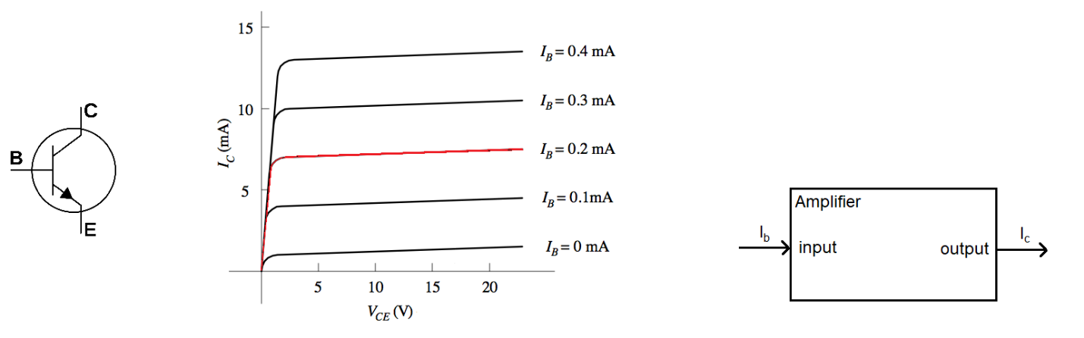

Figure : (A) The three terminals of a transistors labeled. (B) The Ic vs. Vce family of curves for a BJT and the equivalent model. (C) The equivalent model of the transistor.

As shown in Figure 1A a transistor is a three-terminal device; the terminals are named the collector (C), base (B), and emitter (E). When we want to describe the current into a transistor terminal, we use I with a subscript of the terminal. For example, IB is the current flowing into the base. When we want to describe the voltage between two terminals of a transistor, we use V subscripted with the two terminals. For example, the voltage between the collector and emitter is denoted VCE.

Let’s take a moment to make sense of the family of curves shown in Figure 1B then move on to what it means for an oscilloscope to be in X/Y mode and then finally using our BJT Curve Tracer to display the graphs in Figure 1B.

# The Ic vs. Vce family of curves

Instead of looking at all of curves in Figure 1B, let’s focus on the red IB=0.2mA curve and how it relates to the equivalent model shown in Figure 1C. Today, we will view a transistor as the current amplifier shown in Figure 1C. A small input current into the base, IB, is amplified into a large output current into the collector, IC. The gain between input and output is called  and can be anywhere between 30 and 400 depending on the transistor. In other words:

$$I_{C}=βI_{B}$$

The current going into the base and the collector leaves the transistors through the emitter. In our class, we will use transistors as signal amplifiers. In this role, we will want to operate a transistor where the red line is close to horizontal in Figure 1B. This region is called the **active region**. For the red IB=0.2mA curve this means that we need VCE to be greater than 2V – in other words, we want the collector to be at least 2V higher than that emitter to operate the transistor in the active region.

Let’s estimate the gain of the transistor in Figure 1B by estimating the collector current and then forming a ratio with the base current. While the red line is slightly sloped, we can estimate its height at IC=7mA for IB=0.2mA. Thus, the current gain is  = 7mA/0.2mA = 35. Use this graphical technique to complete Table 1. Note, this is a fictitious example, the gain values are usually a lot larger and closer to one another.

Table : The IC and IB values for the family of curves in Figure 1B.

|  |  |  |
| --- | --- | --- |
| IC | IB |  |
| 0.1 mA | 4 mA | 40 |
| 0.2 mA | 7 mA | 35 |
| 0.3 mA | 10 mA | 30 |
| 0.4 mA | 13 mA | 33 |

For the time being, we will stop here in our discussion of transistor behavior. This is a topic that we will explore more in class.

**Oscilloscope in X/Y Mode**

You have mainly used oscilloscopes in time-base mode, which means that the voltage on channel 1 is plotted vs. time. You can imagine that the voltage on channel 1 controls the height of the beam as the beam is being swept across the display. In X/Y mode, the oscilloscope uses the voltage on channel 1 to control the horizontal position (x-axis) of the beam and at the same time, uses the voltage on channel 2 to control the vertical position (y-axis) of the beam.

At first, this sounds really weird and counter-intuitive. However, you can do some pretty useful things with an oscilloscope in X/Y mode, like draw the family of curves for a BJT. To explore this idea further, let’s work the following example. Use the voltages on channel 1 and 2 in Figure 2 to determine what is displayed with the oscilloscope is X/Y mode. In this example:

* Ch 1 is configured to provide x-axis data,
* Ch 2 is configured to provide y-axis data,
* The vertical axis for Ch1 and Ch2 is 1 Volt per division,
* The center horizontal line is set to 0V.

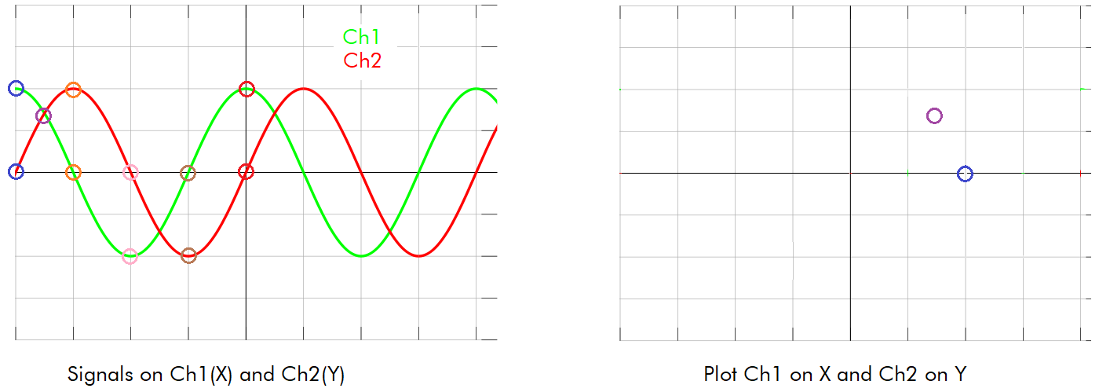

Figure : A pair of signals on Channel 1 and 2. Plot these 2 signals in XY mode.

At the left edge of the screen the values of Ch 1 and 2 are circled in blue, with Ch1=2V and Ch2=0V. So in the right half of Figure 2, a blue circle is placed at (x,y) = (2V, 0V). Note, the X/Y plot has the same scale as its respective channel.

Complete Table 2 by finding the voltages for channel 1 and 2 at the indicated times. Then place these points on the X/Y plot, connect the dots and determine what the user would see.

Table : The X,Y values of the curve in Figure 2.

|  |  |  |
| --- | --- | --- |
| Time | Ch 1 (X) | Ch 2 (Y) |
| Blue | 2 | 0 |
| Purple | 1.4 | 1.4 |
| Orange | 0 | 2 |
| Pink | -2 | 0 |
| Brown | 0 | -2 |
| Red | 2 | 0 |

**Running the BJT Curve Tracer**

In order to use the BJT Curve Tracer, you will need access to an oscilloscope, a test BJT, and a power source. Connect these as shown in Figure 3.

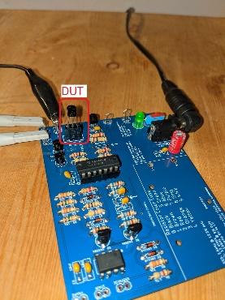

Figure : BJT Curve tracer with DUT inserted into the test fixture and oscilloscope leads connected.

Next you will need to setup your oscilloscope. The following configuration should get you started, but you may need to make adjustment depending on the DUT.

|  |  |
| --- | --- |
| Horizontal (scale) | 1ms |
| Ch1 probe | CH_X |
| Ch1 (scale) | 0.5V/div |
| Ch 1(position) | Lowest reticule |
| Ch2 probe | CH_Y |
| Ch2 (scale) | 0.2V/div |
| Ch 2(position) | Lowest reticule |
| Trigger mode | Auto |

You should see a pretty chaotic set of waveforms like that shown in Figure 4 with activity on both channels. If either channel has no signal, make sure that the DUT is firmly inserted into the test fixture or that you have the DUT inserted backwards (some BJTs have the collector and emitter terminals swapped).

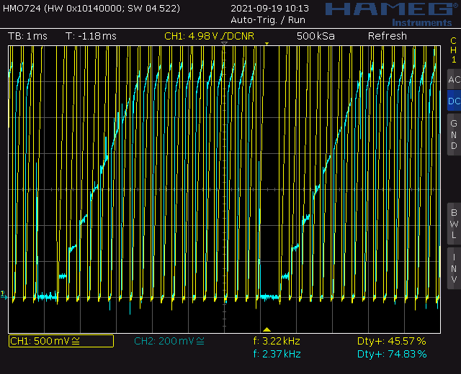

Figure : The oscilloscope output with a DUT in normal model

Next you will need to put the oscilloscope into X/Y mode. Find the Horiz button and then use the softkey menu to select X/Y.

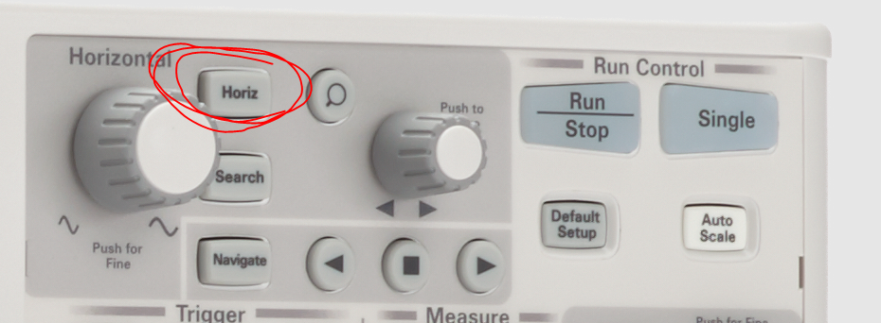

You should see something similar to Figure 5.

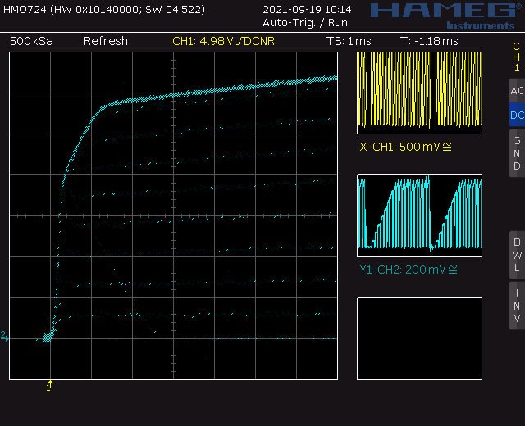

Figure : The BJT family of curves for the DUT.

# Digital oscilloscopes struggle in X/Y mode because they sample their inputs at discrete times and then draw the samples on the display. You can play around with the persistence settings to improve the graph like that shown in Figure 6.

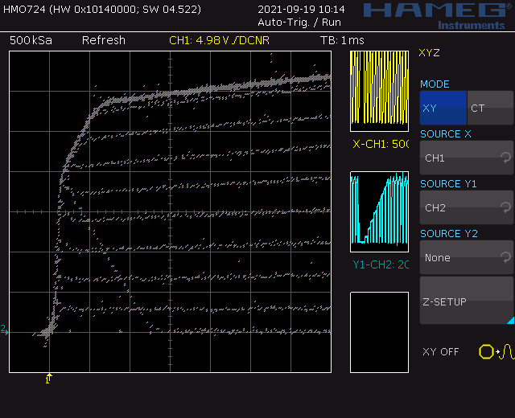

Figure : With some adjustments, you can improve the quality of the oscilloscope display.

# Now that you have your BJT curve tracer working, let’s figure out how to get numerical information from the plot.

# Axis Scale for BJT Curve Tracer:

# The key to determining the scales of the X and Y axis in Figure 6 is the circuit which drives the X and Y signals, shown in Figure 7.

# 

Figure : The signals going into the DUT are measured using 2 channels of an oscilloscope.

**The Vertical Axis Scale – Collector Current**

The pair of transistors Q4 and Q5 in Figure 7 form a circuit called a current mirror. What you need to know right now is that the current flowing from the top to bottom through Q4 is the same as the current flowing from the top to bottom through Q5. Thus, collector current, IC, into the DUT (3-terminal connector marked OUT in Figure 7) is identical to the current flowing through the 220Ω resistor R22. Using ohm’s law on resistor R22 yields Equation 1.

|  |  |  |
| --- | --- | --- |
|  |  |  |

Assuming that you have the channel 2 (Y-scale) of the oscilloscope set to 200mV/division, we can solve for IC and find the number of milliamps per division. This yields Equation 2.

|  |  |  |
| --- | --- | --- |
|  |  |  |

**The Horizontal Axis Scale – Collector Emitter Voltage**

Since the Channel 1 (X-scale) probe is connected to the collector of the DUT (see Figure 7), the scale of the channel probe equals the scale of the horizontal axis. If you used the recommended setup, this is 500mV/division.

**Each Curve – Base Current**

For now, you need to know that a transistor in the active region has a 0.7V drop from the base to the emitter. Since the emitter of the DUT in Figure 7 is grounded, this means that the base of the DUT is at 0.7V when the DUT is in the active region. Let’s call the voltage at the STAIR signal in Figure 7 be VSTAIR, then we can use Ohm’s law to compute the voltage drop from VSTAIR to ground as Equation 3.

|  |  |  |
| --- | --- | --- |
|  |  |  |

Solving for IB yields Equation 4.

|  |  |  |
| --- | --- | --- |
|  |  |  |

# I closely examine the staircase function on an oscilloscope (by probing the STAIR header) in Figure 8 to determine the first non-zero value of VSTAIR is 1.3V. Each subsequent voltage step was about 0.9V high. Use this information to compute the height of each step in the VSTAIR column of Table 3.

# 

Figure : A close zoom of the staircase function with cursors measuring the first step.

# In the IB column of Table 3 use Equation 4 to compute the base current.

# With the base current in hand, I want you to use Equation 2 to determine the collector current for each of these curves in Figure 6 and fill in these values in the IC column of Table 3. To keep your measurements consistent, measure the current where the curve crosses the center reticule of the oscilloscope. For example, the 7th curve up has a collector current of 5mA.

Not that you have the base and collector current for each curve in the family, calculate the current gain, , for each of the 8 curves in Figure 6and record the data in Table 3.

Table : The current gain for each of the family of curves in Figure 6. Fill in IB and IC entries to 2-significant figures. Enter  to 3-significant figures.

|  |  |  |  |
| --- | --- | --- | --- |
| VSTAIR | IB | IC |   IC /IB |
| 1.3V | 1.3uA | 0.6mA | 462 |
| 2.2V | 3.2uA | 1.4mA | 438 |
| 3.1V | 5.1uA | 2.1mA | 412 |
| 4.0V | 7uA | 2.9mA | 414 |
| 4.9V | 8.9uA | 3.6mA | 404 |
| 5.8V | 11uA | 4.4mA | 400 |
| 6.7V | 13uA | 5.0mA | 385 |
| 7.6V | 15uA | 5.7mA | 380 |

**Tuning the Staircase**

# At the outset, you do not need to complete this step of the lab. You can increase the number of curves drawn in Figure 6 by increasing the number of steps. You can increase the number of steps by decreasing the height (in Volts) of each step. To do this you will use the adjustment capacitor in Figure 9.

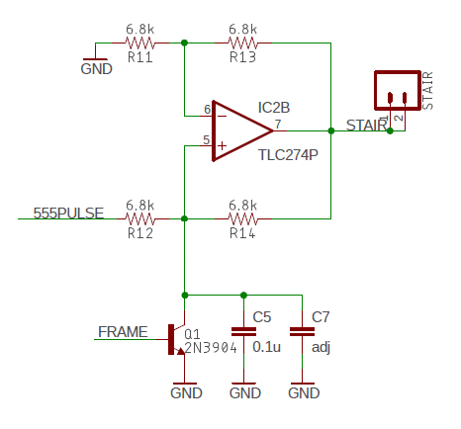

Figure : Circuit to generate the staircase function. Slightly edited from the schematic.

You may remember that the Deboo Integrator takes the integral of the voltage input, in this case the 555-timer output, called 555PULSE, and multiplies it by 2/RC. In terms of Figure 9, the resistor is R12 and the capacitance is the parallel pair C5, C7. Your board is currently configured with no capacitor in the C7 position. By adding a capacitor in C7, you would be adding a capacitor in parallel with C5, thus increase the overall capacitance of the Deboo Integrator. This would then make the term 2/RC smaller. This would then make the integral smaller. This would then make the voltage steps smaller. This would accomplish our goals. You are welcome to experiment with different capacitor values and add one that results in the STAIR output getting to the maximum voltage just before the Deboo Integrator is reset.

Power your BJT curve tracer board from an AC/DC transformer or use the bench power supply set to 9V. Use your oscilloscopes to measure the values of the staircase output from the “STAIR” header adjacent to the 555-timer chip. To do this, you can setup your oscilloscope as follows - please feel free to adjust these settings as needed.

|  |  |
| --- | --- |
| Ch1 probe | STAIR |
| Horizontal (scale) | 500us |
| Ch1 (scale) | 2V/div |
| Trigger mode | Auto |
| Trigger source | 1 |
| Trigger slope | ↑ |
| Trigger level | 4.5V |

To decrease the step height, you will need to add more capacitance. You can do this by adding a capacitor in parallel to C5 (in Figure 9). You can go through the capacitor drawer and try different values. I’d suggest starting with a 0.1uF. This will get you close to using the entire FRAM interval with steps. You will need to carefully record the height of the first step and the voltage between steps so that you can correctly interpret the base current for each curve in the family of curves.

# Turn in:

Make a record of your response to numbered items below and turn them in a single copy as your team’s solution on Canvas using the instructions posted there. Include the names of both team members at the top of your solutions. Use complete English sentences to introduce what each of the following listed items (below) is and how it was derived.

**The Ic vs. Vce family of curves**

Complete Table 1.

**Oscilloscope in X/Y Mode**

Completed Figure 2.

Completed Table 2.

**Running the BJT Curve Tracer**

Your circuit output equivalent to Figure 6.

**Axis Scale for BJT Curve Tracer**

Completed Table 3.

**Analysis of your BJT Curve Tracer**

Measure staircase voltages, similar to Figure 8. Include screenshot from scope using USB.

Complete Table 3 for your circuit.